CS 340 README Template

About the Project/Project Title
This application allows the user to access the database in order to search, and filter the database. THe user are allowed to search the animals given within the local animal shelters by multiple different variations. We were also given a filter by Grazioso Salvarethe to create a dashboard for their company, including their own personalized filter for their preferred rescue breeds. Allowing people to see the geolocation of the dog in order to utilize these animals.

Motivation
We were contracted by Grazioso Salvara for an application that can work from data from animal shelters to identify and categorize available jobs.

Getting Started
This is an example of how you may give instructions on setting up your project locally: “To get a local copy up and running, follow these simple example steps.”

Installation
Latest version of Python, Jyuptr Notebook to run the .py and .ipynb files.
Access to PyMango, Dash libraries to create functions.
MongoDB - to access the database.

Usage
After placing the files within, run the .ipynb files, which then runs the Dash.

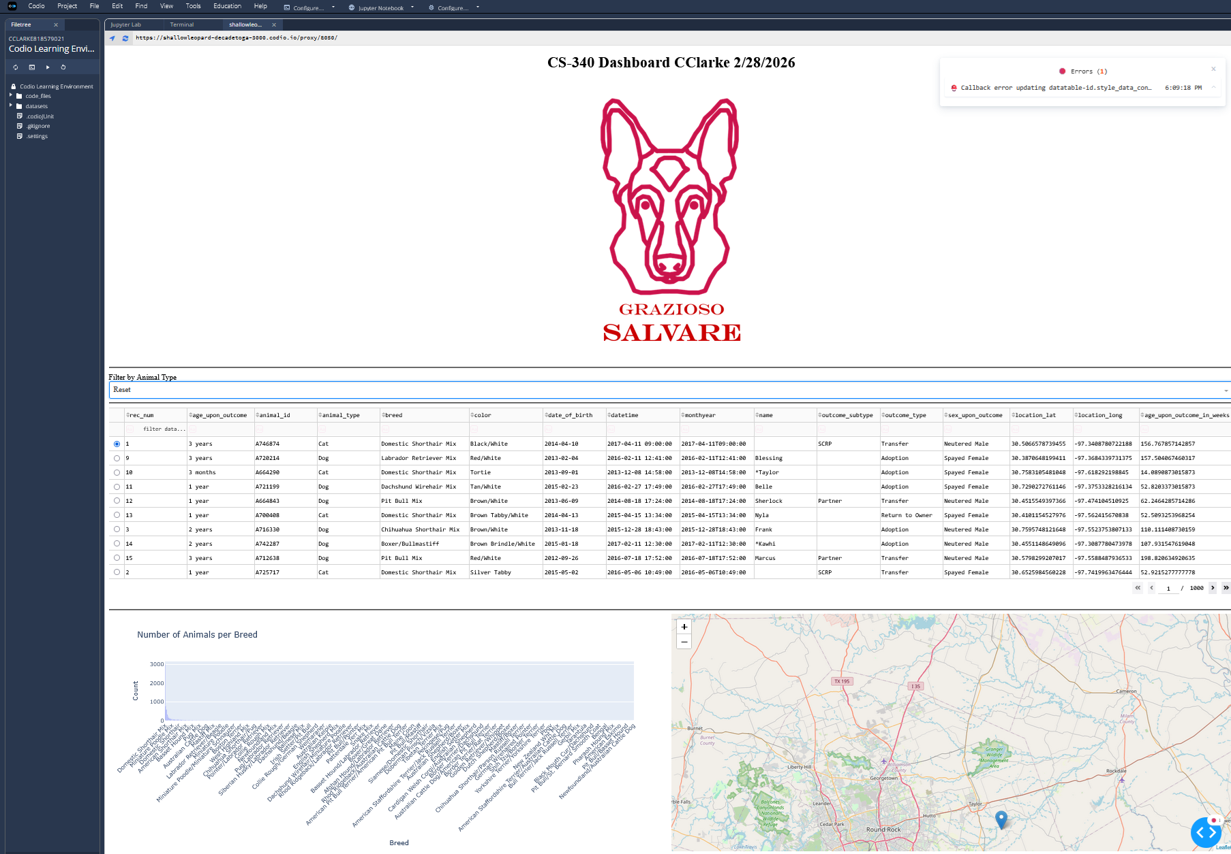

There’s a dropdown menu for the filter for the specific dogs they’re looking to recruit Water Rescue dogs. Clicking on the button causes the filter to geo locate. And the specific looks, gives a bar code for what type of animal breed that is available.

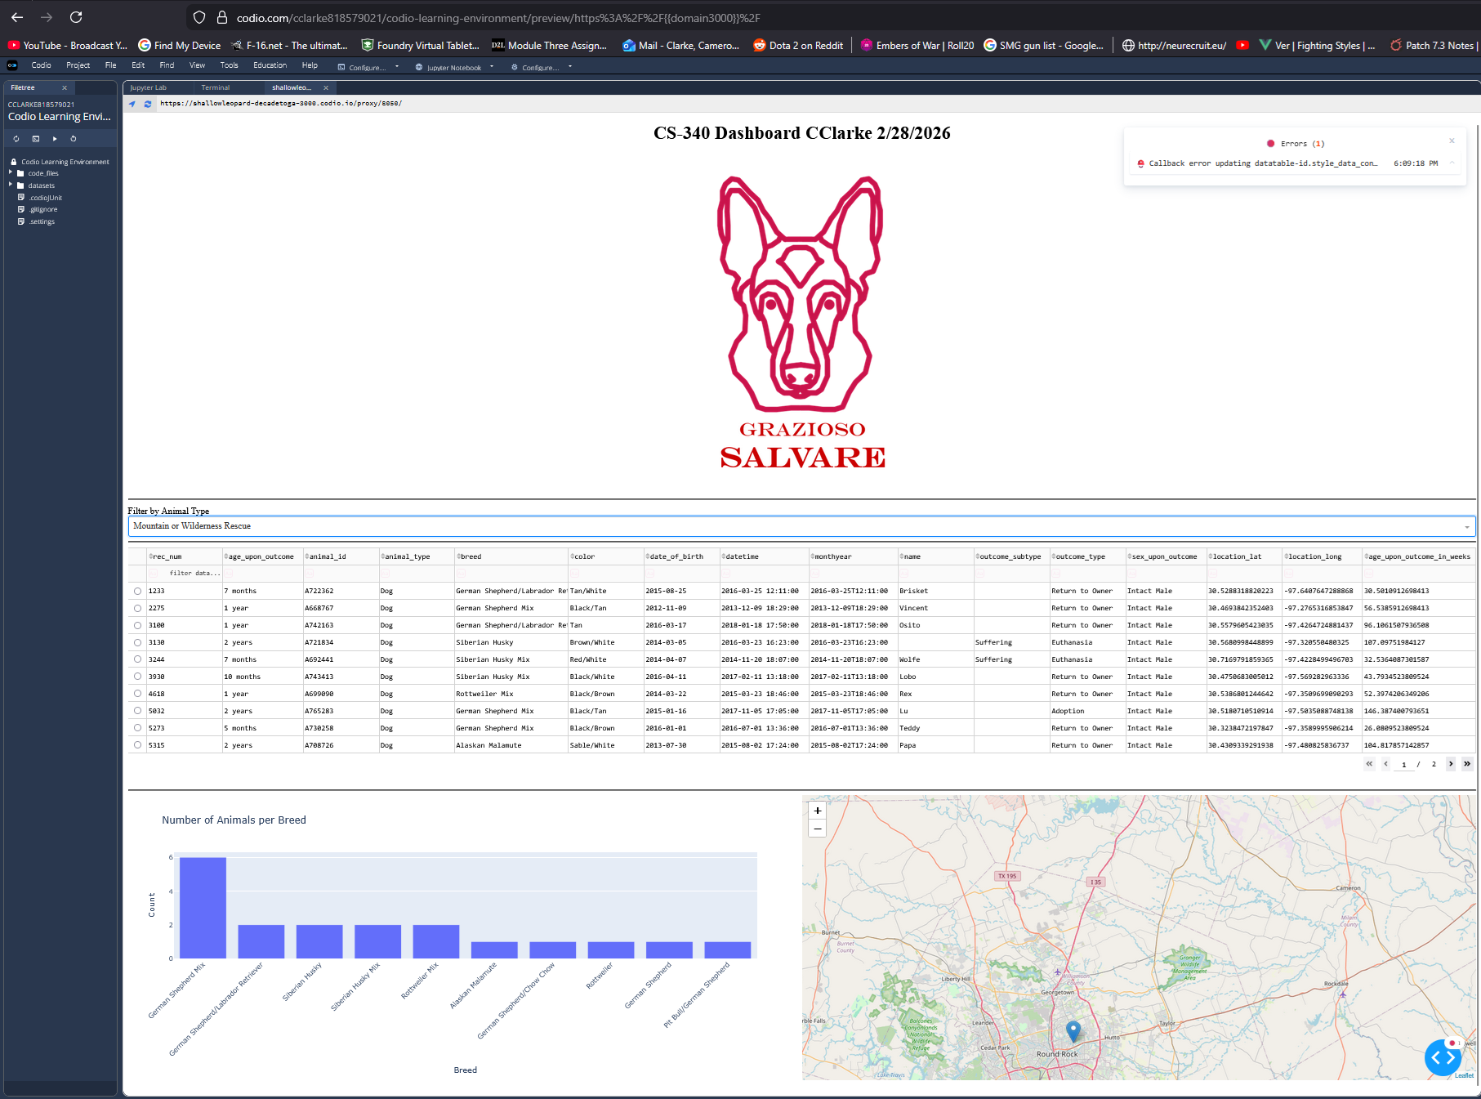

Contact
Your name: Cameron Clarke

